**Hands on 4**

**Spring Core – Load Country from Spring Configuration XML**

PROJECT STRUCTURE: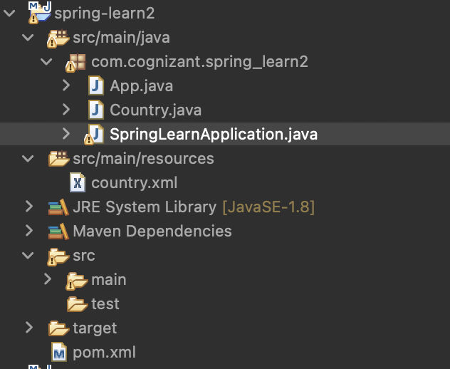

Pom.xml

<project xmlns="http://maven.apache.org/POM/4.0.0" xmlns:xsi="http://www.w3.org/2001/XMLSchema-instance"

xsi:schemaLocation="http://maven.apache.org/POM/4.0.0 http://maven.apache.org/xsd/maven-4.0.0.xsd">

<modelVersion>4.0.0</modelVersion>

<groupId>com.cognizant</groupId>

<artifactId>spring-learn2</artifactId>

<version>0.0.1-SNAPSHOT</version>

<packaging>jar</packaging>

<name>spring-learn2</name>

<url>http://maven.apache.org</url>

<properties>

<project.build.sourceEncoding>UTF-8</project.build.sourceEncoding>

</properties>

<dependencies>

<dependency>

<groupId>junit</groupId>

<artifactId>junit</artifactId>

<version>3.8.1</version>

<scope>test</scope>

</dependency>

<!-- Spring Core -->

<dependency>

<groupId>org.springframework</groupId>

<artifactId>spring-context</artifactId>

<version>5.3.33</version>

</dependency>

<!-- SLF4J and Logback for logging -->

<dependency>

<groupId>org.slf4j</groupId>

<artifactId>slf4j-api</artifactId>

<version>1.7.36</version>

</dependency>

<dependency>

<groupId>ch.qos.logback</groupId>

<artifactId>logback-classic</artifactId>

<version>1.2.11</version>

</dependency>

</dependencies>

</project>

Country.java  
package com.cognizant.spring_learn2;

import org.slf4j.Logger;

import org.slf4j.LoggerFactory;

public class Country {

private static final Logger ***LOGGER*** = LoggerFactory.getLogger(Country.class);

private String code;

private String name;

public Country() {

***LOGGER***.debug("Inside Country Constructor.");

}

public String getCode() {

***LOGGER***.debug("Getting code: {}", code);

return code;

}

public void setCode(String code) {

***LOGGER***.debug("Setting code: {}", code);

this.code = code;

}

public String getName() {

***LOGGER***.debug("Getting name: {}", name);

return name;

}

public void setName(String name) {

***LOGGER***.debug("Setting name: {}", name);

this.name = name;

}

*@Override*

public String toString() {

return "Country{code='" + code + "', name='" + name + "'}";

}

}

SpringApplication.java

package com.cognizant.spring_learn2;

import org.slf4j.Logger;

import org.slf4j.LoggerFactory;

import org.springframework.context.ApplicationContext;

import org.springframework.context.support.ClassPathXmlApplicationContext;

public class SpringLearnApplication {

private static final Logger ***LOGGER*** = LoggerFactory.*getLogger*(SpringLearnApplication.class);

public static void main(String[] args) {

***LOGGER***.debug("START");

*displayCountry*();

***LOGGER***.debug("END");

}

public static void displayCountry() {

ApplicationContext context = new ClassPathXmlApplicationContext("country.xml");

Country country = context.getBean("country", Country.class);

***LOGGER***.debug("Country : {}", country.toString());

}

}

<?**xml** version=*"1.0"* encoding=*"UTF-8"*?>

<**beans** xmlns=*"http://www.springframework.org/schema/beans"*

xmlns:xsi=*"http://www.w3.org/2001/XMLSchema-instance"*

xsi:schemaLocation=*"http://www.springframework.org/schema/beans*

*http://www.springframework.org/schema/beans/spring-beans.xsd"*>

<**bean** id=*"country"* class=*"com.cognizant.spring_learn2.Country"*>

<**property** name=*"code"* value=*"IN"* />

<**property** name=*"name"* value=*"India"* />

</**bean**>

</**beans**>

Output: